CONTENTS:
1. Safety precautions and procedures…………………………………………………… 1
  - Preliminary……………………………………………………………………………… 1
  - During Use……………………………………………………………………………… 2
  - After Use……………………………………………………………………………….. 2
- General Description………………………………………………………………………. 3
- Preparation for Use……………………………………….………………………………. 3
  - Initial………………………………………….…………………………………………. 3
  - Supply Voltage…………………………………………………………………………. 3
  - Calibration………………………………………..…………………………………….. 3
3.4. Storage…………………………………………………………………………………. 3
- Operating Instructions…………………………………………………………………… 4
  - Instrument Description………………………………………………………………… 4
  - Measurement Description…………………………………………………………….. 4
    - DC Voltage measurement……………………………………………………… 4
    - AC Voltage measurement……………………………………………………… 5
    - DC Current measurement……………………………………………………… 5
    - AC Current measurement………………………………………………… 6
    - Resistance measurement……………………………………………………… 6
    - Continuity Test………………………………………………………………….. 7
    - Diode test ………………………………………………………………………. 7
    - Battery Test……………………………………………………………………… 7
    - Capacitance measurement ……………………………………………………..7
  - Preventive Maintenance……………………………………………………………… 8
    - General information…………………………………………………………….. 8
    - Battery replacement………………………………………………………….. 8
    - Fuses replacement…………………………………………………………….. 8
    - Cleaning…………………………………………………………………………. 8
- Technical specifications…………………………………………………………………. 9
  - Characteristics…………………………………………………………………………. 9
    - DC Voltage………………………………………………………………………. 9
    - AC Voltage………………………………………………………………………. 9
    - DC Current………………………………………………………………………. 9
    - AC Current………………………………………………………………………. 9
    - Resistance………………………………………………………………………. 10
    - Capacitance……………………………………………………………………….10
    - Diode…….………………………………………………………………………. 10
    - Continuity test…….…………………………………………………………….. 10
    - Battery test….………………..…………………………………………………. 10
    - Safety…….……………………………………………………………………. 10
    - General data……………..……..…………………………………………… 10
  - Environmental conditions……………….…………………………………………….. 11
    - Climatic conditions………….….…..…………………………………………… 11
    - EMC………………………………………………………………………………. 11
  - Accessories…………………………………………………………………………….. 11
    - Standard accessories…………………………………………………………... 11
- Service……………….…………………………………………………………………….. 12
  - Warranty conditions …… ..……………………………………………………………… 12
  - Service…………. ………………………………………………………………………… 12
- Do not test or connect to any circuit with voltage or current exceeding the specified overload protection.
- Check if the battery is installed correctly.
- Prior to connecting the test probes to the installation, check that the function selector is positioned on the required measurement.

  - DURING USE
Read the recommendation which follow and the instruction in this manual:

WARNING
Non compliance with the warnings and/or the instructions for use may damage the apparatus and/or its components or injure the operator.

- When measuring voltage ensure that the instrument is not switched to a current or resistance range. Always ensure that the correct terminals are used for the type of measurements to be made.
- When changing range, first disconnect the test leads from the circuit under test in order to avoid any accident.
- When the apparatus is connected to the measuring circuits never touch an unused terminal.
- When measuring resistor, please do not add any voltage. Though there is a protection circuit, excessive voltage will still cause malfunction.
- It should discharge the capacitor before the capacitance measurement in order to avoid the high voltage damaging the meter.
- When measuring current ensure that the circuit is powered off before opening it in order to connect test leads.
- This meter is not available for non-sine wave AC voltage or AC current measurements.

  - AFTER USE
- Once the measurements are completed, remove the leads from the input terminals.
- If the instruments is not be used for a long period, remove the batteries.

-2-
5.2. ENVIRONMENTAL CONDITIONS

5.2.1. Climatic conditions
Reference temperature: 23° ± 5°C (accuracy tested temperature)
Operating and storage temperature: -5 ~ 40°C
Operating and storage humidity: <75% RH

5.2.2. EMC
This apparatus was designed in accordance with EMC standards in force and its compatibility has been tested in accordance with the following standards: EN55022, EN50082- 1.
This product conforms to the prescriptions of the European directive on low voltage 73/23/EEC and to EMC directive 89/336/EEC, amended by 93/68/EEC.

5.3. ACCESSORIES

5.3.1 Standard accessories
The accessories contained inside the packaging are the following:
- Instrument
- Batteries
- Test leads
- Instruction manual

-11-
- OPERATING INSTRUCTIONS

4.1. INSTRUMENT DESCRIPTION
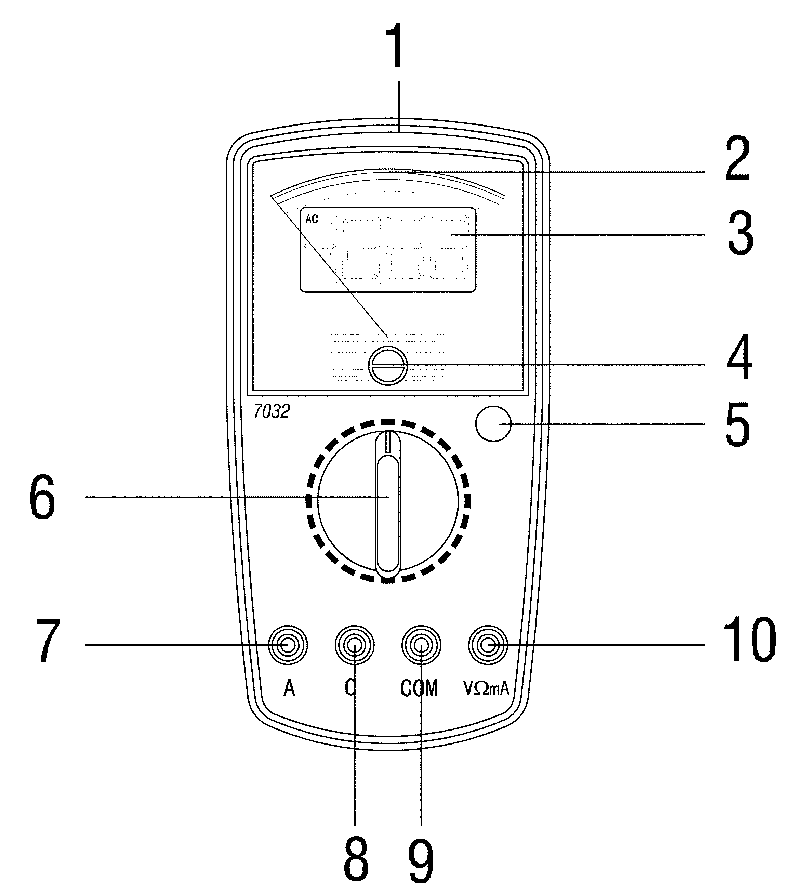

LEGEND:
- Case.
- Analog display.
- Digital display
- Mechanical zero adjustment.
- AC/DC change-over button.
- Rotary switch.
- A terminal.
- C terminal.
- COM terminal.
- VmAΩ C terminal.

Fig. 1: Instrument description.

4.2. MEASUREMENT DESCRIPTION

4.2.1. DC Voltage measurement

WARNING
Maximum input for DC voltage is 600V .Do not attempt to take any voltage measurement that exceeds the limits. Exceeding the limits could cause electrical shock and damage the multimeter.

- Select a proper range for DC voltage (200mV、2、20、200、600 DCV).Press AC/DC change-over button.
- If the voltage range is not known beforehand, set the range switch to the highest range and work down.
- Insert the test leads into the jack, the red plug into VmAΩ jack, and black plug into COM jack.
- Insert the two long ends of test leads to the desired circuit, then reading will be displayed in the digital display window, meanwhile, the analog pointer will show the corresponding reading on scale.

-4-
- TECHNICAL SPECIFICATIONS

5.1. CHARACTERISTICS
Accuracy is indicated as ±[% of reading].
It is referred to the following reference conditions: 23°C ± 5°C with RH<75%.

5.1.1. DC Voltage
Range |  | Resolving power | Accuracy
  DC Voltage  V | 200.0mV | 0.1mV | Digital | Analog
 | 2.000V | 0.001V | ± (0.5% +2) | ± (3% full range )
 | 20.00V | 0.01V | ± (0.5% +2) | ± (3% full range )
 | 200.0V | 0.1V | ± (0.5% +2) | ± (3% full range )
 | 600V | 1V | ± (0.8% +3) | ± (3% full range )
Input impedance 10MΩ; Over load protection: 600V DC/AC peak.
5.1.2. AC Voltage
Range |  | Resolving power | Accuracy
 |  | Resolving power | Digital | Analog
AC Voltage  V ~ | 200.0mV | 0.1mV | ± (1.2% +3) | ± (3% full range)
AC Voltage  V ~ | 2.000V | 0.001V | ± (0.8% +3) | ± (3% full range)
AC Voltage  V ~ | 20.00V | 0.01V | ± (0.8% +3) | ± (3% full range)
AC Voltage  V ~ | 200.0V | 0.1V | ± (0.8% +3) | ± (3% full range)
AC Voltage  V ~ | 600V | 1V | ± (1.2% +3) | ± (3% full range)
Frequency response 40~400Hz;
Input impedance 10MΩ; Over load protection: 600V DC/AC peak.
5.1.3. DC Current
Range |  | Resolving power | Accuracy
 |  | Resolving power | Digital | Analog
DC Current  A | 2.000mA | 0.001mA | ± (1.0% +3) | ± (3% full range)
 | 20.00mA | 0.01mA | ± (1.0% +3) | ± (3% full range)
 | 200.0mA | 0.1mA | ± (1.2% +3) | ± (3% full range)
 | 10A | 0.01A | ± (2.0% +3) | ± (3% full range)
Voltage drop: 0.2V Fuse: F 200mA/250V, 10A/250V
5.1.4. AC Current
Range |  | Resolving power | Accuracy
 |  | Resolving power | Digital | Analog
AC Current  A ~ | 2.000mA | 0.001mA | ± (1.5%+3 ) | ± (3% full range)
AC Current  A ~ | 20.00mA | 0.01mA | ± (1.5%+3 ) | ± (3% full range)
AC Current  A ~ | 200.0mA | 0.1mA | ± (1.8%+3 ) | ± (3% full range)
AC Current  A ~ | 10A | 0.01A | ± (2.5%+3 ) | ± (3% full range)
Voltage drop: 0.2V Frequency response: 40~400Hz
Fuse: F 200mA/250V, 10A/250V

-9-
4.2.4. AC Current measurement

WARNING
Make sure that circuit under test in powered off before open it to insert test leads. Do not attempt to take any current measurements in circuits power with more than 240V
- Power off the circuit under test.
- Select a proper range for AC current (2,20,200mA,10A), then re-press AC/DC change-over button. If the current range is not known beforehand, set the range switch to the highest range and work down.
- Insert the test leads into the jack, the black plug into COM jack, and the red plug into the jack corresponding the position chosen with the rotary switch VmAΩ jack for 2,20,200mA ranges or 10A jack for 10A range.
- Insert the two test leads in series with the lead in which the current is to be measured.
- Power on the circuit under test.
- The reading will be displayed in the digital display window, meanwhile, the analog pointer will show the corresponding reading on scale.
- If the analog pointer doesn’t move and no display during current measurement check the fuses inside the multimeter and replace them if necessary (ref. Paragraph 4.3.3).

    - Resistance measurement

WARNING
Before taking any in circuit resistance measurement, remove power from the circuit being tested and discharge all the capacitors.

- Select a proper coefficient for Resistance measuring (200,2k,20k,200k,2M,20MΩ).
- Insert the test leads into the jack, the red plug into VmAΩ jack. and black plug into COM jack.
- Insert the two long ends of test leads to the desired circuit, then reading will be displayed in the digital display window, meanwhile, the analog pointer will show the corresponding reading on scale.
- As measuring resistance, any voltage existing in circuit is not allowed. If a capacitor is installed, it must be discharged before test.
    - Continuity test

WARNING
Before taking any in circuit resistance measurement, remove power from the circuit being tested and discharge all the capacitors.
- Select the position.
- Insert the test leads into the jack, the red plug into VmAΩ jack, and black plug into COM jack.
- Insert the two long ends of test leads to the desired circuit, the instruments will emit an acoustic signal when the reading will be lower than 30Ω approx.
- As measuring resistance, any voltage existing in circuit is not allowed. If a capacitor is installed, it must be discharged before test.
-6-

    - Diode Test

WARNING
Before testing diode, remove power from the circuit being tested and discharge all the capacitors.
- Select the position.
- Insert the test leads into the jack, the red plug into VmAΩ jack, and black plug into COM jack.
- Insert the two long ends of test leads to the desired circuit, then reading will be displayed in the digital display window, meanwhile, the analog pointer will show the corresponding reading on scale, its display value is to the positive potential drop of the diode.
- When measuring diode, any voltage existing in circuit is not allowed, If a capacitor is installed, it must be discharged before test.

4.2.8. Battery test

WARNING
Before testing battery, take out the battery from equipment first. In this range, do not attempt to take any voltage measurement more than 20V.
- Select BATT position. Insert the test leads into the jack, the red plug into VmAΩ jack, and the black plug into COM jack.
- Connect the two long ends of test leads to the desired battery, the red plug to positive and the black plug to negative, the reading will be displayed in the digital display window, meanwhile, the analog pointer will show the corresponding reading on scale.
- When testing battery, do not take any voltage measurement more than 20V.

4.2.9. Capacitance test

WARNING
Before taking capacitance measurement, disconnect the capacitor from circuit and ensure the capacitor is discharged, do not attempt to take any voltage measurement more than 20V.
- Select a proper range for capacitance (2,20,200nF,2,20μF)
- Insert the test teads into the jack, the red plug into VmAΩ jack, and black plug into C jack.
- Insert the two long ends of test leads to the desired capacitor, the reading will be displayed in the digital display window, meanwhile, the analog pointer will show the corresponding reading on scale.
- When taking capacitance measurement, any voltage existing in capacitor is not allowed, it must be discharged before test in case the voltage into test leads.
- If the analog pointer doesn't move and no display during capacitance measurement check the fuses inside the muiltimeter and replace them if nesessary (ref. Paragraph 4.3.3).
-7-

7032
Digital-Analog Multimeter
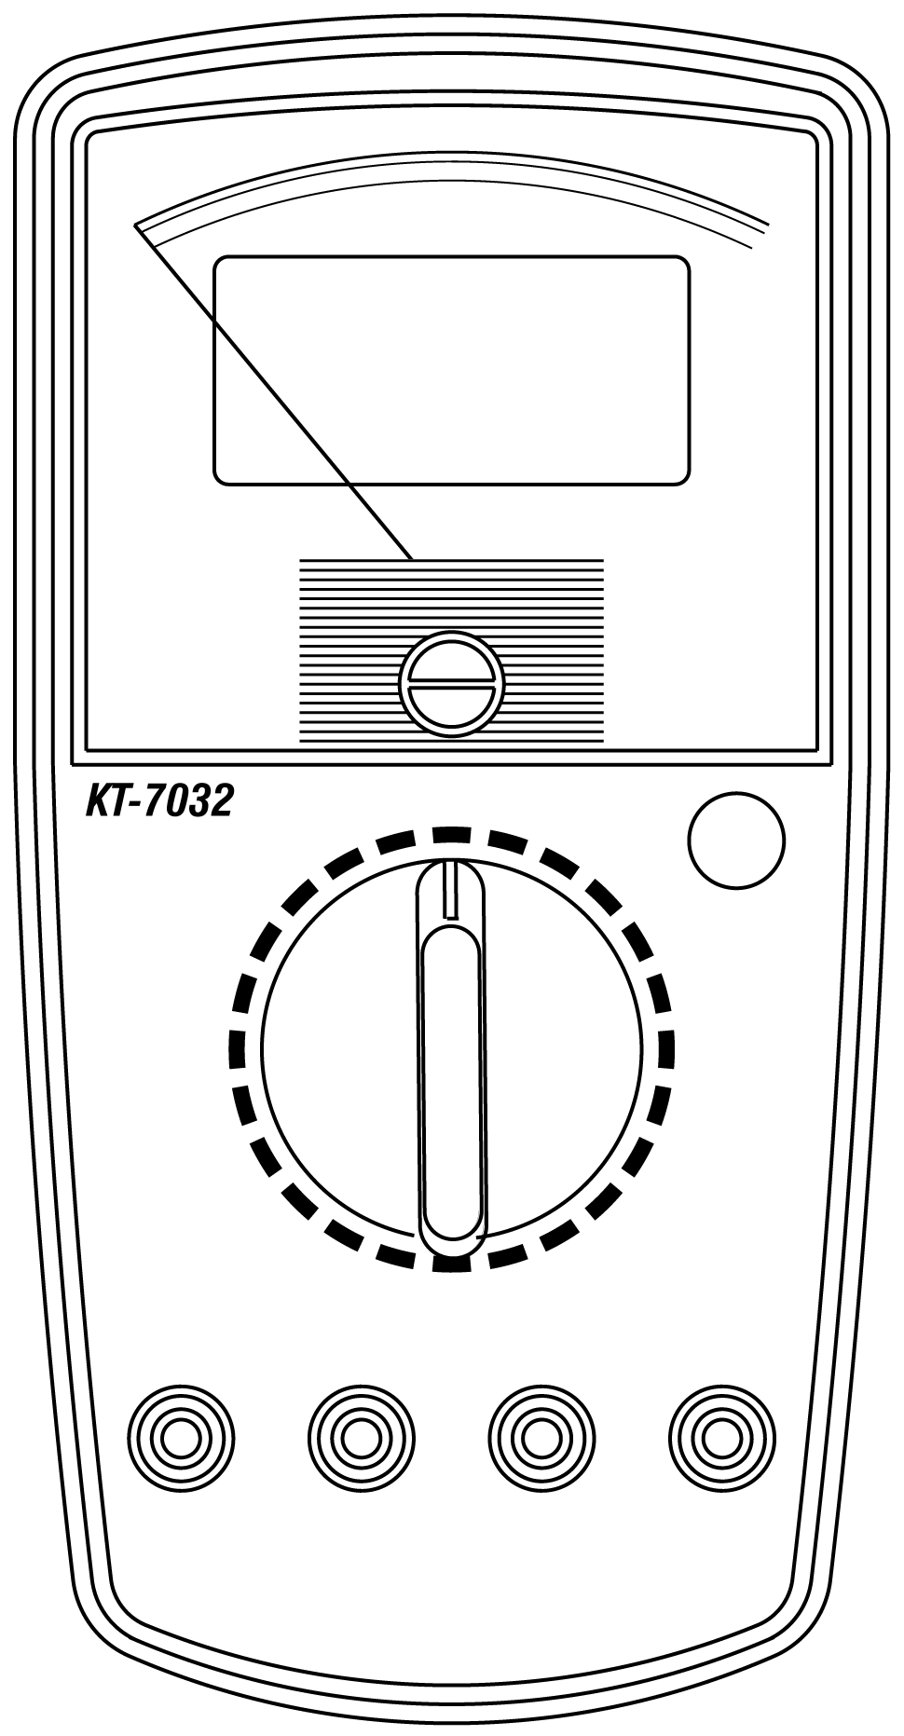

OPERATOR’S MANUAL

- .SERVICE

6.1. WARRANTY CONDITIONS
This equipment is guaranteed against any material fault or manufacturer’s defect, in accordance with the general conditions of sale. During the warranty period (one year), faulty parts may be replaced, with the manufacturer reserving the right to decide either to repair or replace the product.
In the event of returning the equipment to the after-sales service or to a regional branch, the outward transport is payable by the customer. The delivery must be agreed in advance with consignee.
For delivery indicate by means a note enclosed with the equipment, as clear as possible, the reasons for returning it use only the original packing.
Any damaging caused by shipment using NOT original packaging will be charged in any case to the consignor.
The manufacturer will not be responsible for any damage against persons or things.

The warranty doesn’t apply to the following cases:
- Accessories and batteries aren’t include in warranty.
- Repairs following unsuitable use of the equipment or by combining the latter with incompatible equipment.
- Repairs resulting from a not correct shipping.
- Repairs resulting from servicing carried out by a person not approved by the company.
- Modifications to the equipment without explicit authorisation from our technical departments.
- Adaptation to a particular application not provided for by the definition of the equipment or by the instruction manual.

The contents of this manual may not be reproduced in any form whatsoever without our agreement.
Our products are patented. The logotypes are registered. We reserve the right to modify characteristics and prices as part of technological developments which might require them.

6.2. SERVICE
If the equipment shouldn’t work correctly, before contacting the SERVICE, test the batteries condition, the test leads, etc., and change them if necessary.
If the equipment still doesn’t work check if your operating procedure agrees with the latter described in the manual.

In the event of returning the equipment it must be re-sent to the after-sales service (at address or to a regional branch), the outward transport is payable by the customer. The delivery must be agreed in advance with consignee.
For delivery indicate by means a note enclosed with the equipment, as clear as possible, the reasons for returning it use only the original packing.
Any damage caused by delivery with NO original packaging will be charged in any case to the consignor.
-12-
- SAFETY PRECAUTIONS AND PROCEDURES
This apparatus conforms to safety standard EN 61010-1,relating to electronic measuring instruments.

For your own safety and that of the apparatus, you must follow the procedures described
in this instruction manual and especially read all the notes preceded by the symbol
carefully.
Take extreme care for the following conditions when measuring:
- Do not measure voltage, current under humid or wet environment.
- Do not operate the meter under the environment with explosive gas (material), combustible gas (material), steam or filled with dust.
- Keep you insulated from the object waiting for measuring.
- Do not contact any exposed metal (conductive) parts such as end of test lead, socket, fixing object, circuit, etc.
- To prevent mechanical damage of analog pointer coil and digital display do not submit the instrument to vibration or shock.
- To prevent damage of digital display do not expose meter to direct sunlight.
- If any unusual condition of testing end (metal part) and attachment of the meter such as breakage, deformation, fracture, foreign substance, no display, etc., do not conduct any measuring.
- Measuring voltage over 20V because it might cause human body electricity conduction.

The followings symbols are used:

Caution: Refer to the instruction manual. Incorrect use may damage the apparatus or its components.

Danger high voltage: Risk of electric shock.

Meter double insulated.

DC voltage or current.

AC voltage or current.

  - PRELIMINARY
- This apparatus has been designed for use in an environment of pollution degree 2.
- It can be used for VOLTAGE measurements on installations of surge voltage category II up to 600 volts.
- You must comply with the usual safety regulations aimed at:
- Protecting you against the dangerous electric current.
- Protecting the instrument against an incorrect operation.
- Only the leads supplied with the instrument guarantee compliance with the safety standard. They must be in a good condition and they must be replaced, if necessary with an identical model.
-1-
5.1.5. Resistance
Range |  | Resolving power | Accuracy
 |  | Resolving power | Digital | Analog
Resistance  Ω | 200.0Ω | 0.1Ω | ± (1.2%+5 ) | ± (3% full range)
Resistance  Ω | 2.000kΩ | 0.001kΩ | ± (0.8%+3 ) | ± (3% full range)
Resistance  Ω | 20.00kΩ | 0.01kΩ | ± (0.8%+3 ) | ± (3% full range)
Resistance  Ω | 200.0kΩ | 0.1kΩ | ± (0.8%+3 ) | ± (3% full range)
Resistance  Ω | 2.000MΩ | 0.001MΩ | ± (0.8%+3 ) | ± (3% full range)
Resistance  Ω | 20.00MΩ | 0.01MΩ | ± (1.2%+5 ) | ± (3% full range)
Over load protection: 250V DC/AC peak
5.1.6. Capacitance
Range |  | Resolving power | Accuracy
 |  | Resolving power | Digital | Analog
Capacitance  C | 2.000 nF | 0.001 nF | ± (2.5%+5 ) | ± (3% full range)
Capacitance  C | 20.00 nF | 0.01 nF | ± (2.5%+5 ) | ± (3% full range)
Capacitance  C | 200.0 nF | 0.1 nF | ± (2.5%+5 ) | ± (3% full range)
Capacitance  C | 2.000 μF | 0.001 μF | ± (2.5%+5 ) | ± (3% full range)
Capacitance  C | 20.00 μF | 0.01 μF | ± (2.5%+5 ) | ± (3% full range)
Over load protection: 250V DC/AC peak
5.1.7. Diode test
Test Current: 1.0±0.6mA
Test Voltage: Approx 2.4V
5.1.8. Continuity test
Audible indication: less than 30Ω approx
Test Voltage: Approx 2.4V
5.1.9. Battery test
1.5V load current: When resistance load is 15Ω, the discharge
current is 100mA approx .
9V load current: When resistance load is 900Ω, the discharge
current is 10mA approx.
5.1.10. Safety
Comply with: EN61010- 1.
Insulation: Class 2, double reinforced insulation.
Pollution: Level 2.
For inside use, max height: 2000m.
Over voltage: CAT III 600V
    - General data
Mechanical characteristics
Size: 180(W) x 91(H) x 48(D) mm.
Weight (not including holster): 330g
Battery type: 1x9V IEC 6F22
Fuses: 5x 20mm 0.2A/250V Fast Acting
6x 25mm 10A/250V Fast Acting
Display Type: Digital display
Analog display.
-10-
- GENERAL DESCRIPTION

Dear customer, we thank you for your patronage. The multimeter you have just purchased will grant you accurate and reliable measurements provided that it is used according to the present manual’s instructions.
The apparatus can perform the following measurement.
- AC values of voltage (V_{AC})
- DC values of voltage (V_{DC})
- AC values of current (I_{AC})
- DC values of current (I _{DC})
- Resistance values.
- Capacitance
- Diode test
- Continuity Test
- Battery test.
Each of these functions and parameters can be selected by means of a 24-position rotary and a AC/DC change-over button.

- PREPARATION FOR USE

  - INITIAL
All the equipment has been checked mechanically and electrically prior to shipment.
Every care has been taken to ensure that the instrument reaches you undamaged.
However, it is wise to carry out a rapid check in order to detect any possible damage which might have been caused during transport. Should this be the case, immediately enter the usual claims with courier.
Check the packaging contained according to packaging list reported in paragraph 5.3.1. In case of discrepancies contact the dealer.
In the event of re-shipment of the equipment please follow the instructions reported in paragraph 6.

  - SUPPLY VOLTAGE
The instrument is battery supplied; It use one model 9V IEC 6F22 battery. It is about 200 hours of continuos work.

  - CALIBRATION
The instrument fulfils the technical characteristics listed in this manual. The performances of the specifications are guaranteed for one year.

  - STORAGE
In order to guarantee the accuracy of the measurements, after a period of storage in extreme environment condition, wait for the time necessary so that the apparatus returns to normal measuring conditions (see environments specifications paragraph 5.2.1).

-3-
4.3. PREVENTIVE MAINTENANCE

4.3.1. General information
- This multimeter is a precision instrument. Whether in use or in storage, please do not exceed the specification requirements to avoid any possible damage or danger during use.
- Do not place this meter in high temperature or humidity or high magnetic field or expose to direct sunlight.
- Be sure to turn the meter off after use. For long time storage, remove the battery to avoid leakage of battery liquid that would damage the interior parts.
- To prevent mechanical damage of analog pointer coil do not submit the instrument to vibration or shock.

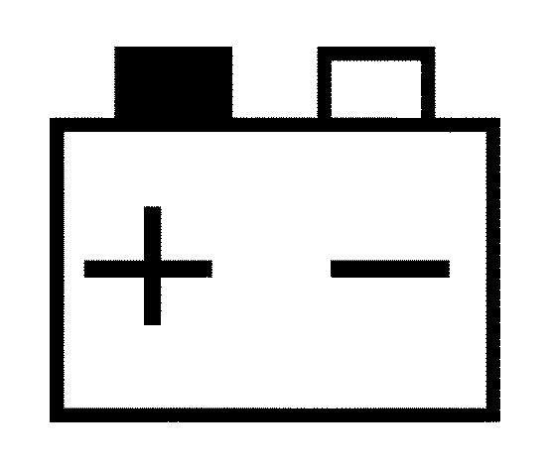
4.3.2. Battery replacement
When the meter displayed " "in digital display window replace battery.

WARNING
Before attempting batteries removal disconnect test leads from any energized circuits to avoid electrical shock.

- Disconnect the test leads from the circuit under test.
- Remove the screws from the battery cover, and detach the battery covers from the bottom cover.
- Remove the battery and replace it with new ones of the same type (9V 6F22 )x1 observing the proper polarity from the diagram inside the battery compartment.
- Replace the battery cover and screws.

4.3.3. Fuses replacement

WARNING
Before attempting fuses removal disconnect test leads from any energized circuits to avoid electrical shock.

- Disconnect the test leads from the circuit under test.
- Remove the screws from bottom cover, take out the fuses.
- Replace the fuses with new ones only with identical type and rating (0.2A/250V and 10A/250V).
- Replace the bottom cover and the screws.

4.3.4. Cleaning
For cleaning the instrument use a soft dry cloth. Never use a Wet cloth, solvents or water, etc.

-8-

    - AC Voltage measurement

WARNING
Maximum input for AC voltage is 600V ~ .Do not attempt to take any voltage measurement that exceeds the limits. Exceeding the limits could cause electrical shock and damage the multimeter.

- Select a proper range for AC voltage (200mV,2,20,200 or 600 ACV). Then re-press AC/DC change-over button.
- If the voltage range is not known beforehand, set the range switch to the highest range and work down.
- Insert the test leads into the jack, the red plug into VmAΩ jack, and black plug into COM jack.
- Insert the two long ends of test leads to the desired circuit, then reading will be displayed in the digital display window, meanwhile, the analog pointer will show the corresponding reading on scale.

    - DC Current measurement

WARNING
Make sure that circuit under test is powered off before open it to insert test leads. Do not attempt to take any current measurements in circuits power with more than 240V.

- Power off the circuit under test.
- Select a proper range for DC current (2, 20, 200mA, 10A). Press AC/DC change-over button. If the current range is not known beforehand, set the range switch to the highest range and work down.
- Insert the test leads into the jack; the black plug into COM jack and the red plug into the jack corresponding the position chosen with the rotary switch (VmAΩ jack for 2, 20, 200mA ranges or 10A jack for 10A range).
- Insert the two test leads in series with the load in which the current is to be measured.
- Power on the circuit under test.
- The reading will be displayed in the digital display window, meanwhile, the analog pointer will show the corresponding reading on scale.
- If the analog pointer doesn’t move and no display during current measurement check the fuses inside the multimeter and replace them if necessary (ref. Paragraph 4.3.3).

-5-

